Name _______________

Make Your Own Circus Poem
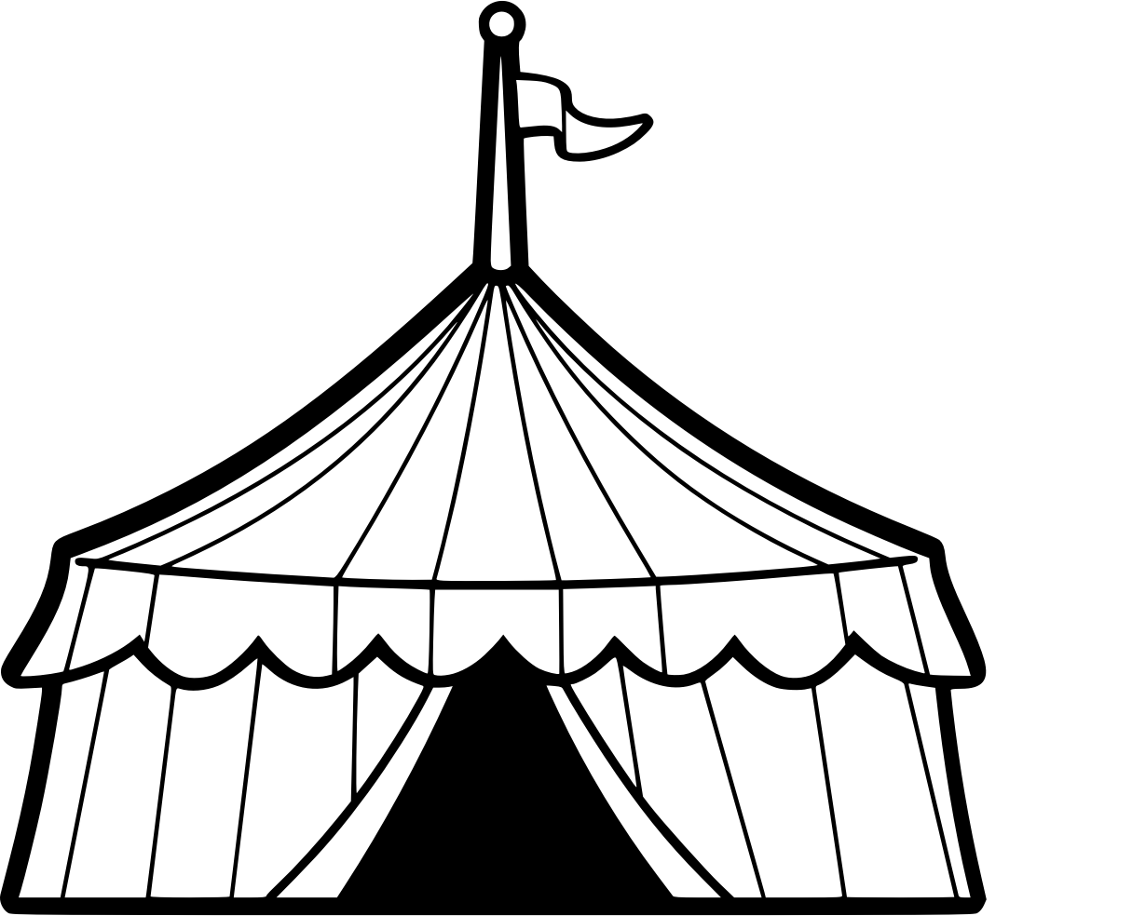

- What color do you think of when you hear the word “circus’? _________________
- What would a circus smell like? __________________________
- What would you hear? __________________________
- What food would you eat at a circus? __________________________
- What animal would they have at a circus? __________________________
- What performance would you see? __________________________
- What do the costumes look like? __________________________
- How would you feel at a circus? __________________________

Write your answers on the blanks:

Circus
_____________________
_____________________
_____________________
_____________________
_____________________
_____________________
_____________________
_____________________
Circus

