Name: __________________

Traveling circuses used to be popular and performers went all across the country. Imagine you are the ringmaster of a circus and you were wearing this costume. How would it feel? Is it heavy or scratchy?
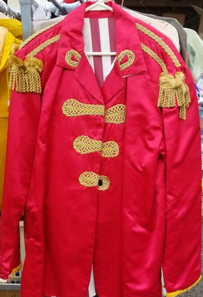

Describe what you think it would be like to wear a ringmaster’s costume.
____________________________________________________________________________________________________________________________________________________________________________________________________________________________________________________________________________________________________________________________________________________________________________________________________________________________________________________________________________________________________________________________________________________________________________________________________________________________________________________________________________________________________________________________________________________________________________________________________________________________________________________________________________________________________________________________________________________________________________________________________________________________________________________________________________________________________________________________________________________________________________________

